**Advance Android - II**

**Lab-1**

**Fragments**

**Activity main**

*<?***xml version="1.0" encoding="utf-8"***?>*

<**LinearLayout xmlns:android="http://schemas.android.com/apk/res/android"**

**xmlns:app="http://schemas.android.com/apk/res-auto"**

**xmlns:tools="http://schemas.android.com/tools"**

**android:layout_width="match_parent"**

**android:layout_height="match_parent"**

**tools:context=".MainActivity"**

**android:orientation="vertical"**>

<**ImageView**

**android:layout_width="100dp"**

**android:layout_height="100dp"**

**android:layout_gravity="center_horizontal"**

**android:layout_margin="20dp"**

**android:src="@drawable/logo"**/>

<**FrameLayout**

**android:layout_width="match_parent"**

**android:layout_height="match_parent"**

**android:id="@+id/frag1"**>

<**LinearLayout**

**android:layout_width="match_parent"**

**android:layout_height="match_parent"**

**android:orientation="vertical"**>

<**EditText**

**android:layout_width="match_parent"**

**android:layout_height="50dp"**

**android:layout_margin="20dp"**

**android:inputType="textWebEmailAddress"**

**android:padding="10dp"**

**android:hint="Username or Email"**/>

<**EditText**

**android:layout_width="match_parent"**

**android:layout_height="50dp"**

**android:layout_margin="20dp"**

**android:inputType="textPassword"**

**android:padding="10dp"**

**android:hint="Password"**/>

<**Button**

**android:layout_width="match_parent"**

**android:layout_height="50dp"**

**android:layout_marginHorizontal="100dp"**

**android:layout_marginVertical="20dp"**

**android:padding="10dp"**

**android:text="Login"**

**android:textAllCaps="false"**

**android:textColor="#fff"**

**android:textStyle="bold"**

**android:textSize="24dp"**

**android:background="#4683BA"**

**android:alpha=".8"**/>

<**Button**

**android:layout_width="match_parent"**

**android:layout_height="50dp"**

**android:layout_marginHorizontal="100dp"**

**android:padding="10dp"**

**android:text="Sign Up"**

**android:textAllCaps="false"**

**android:textColor="#fff"**

**android:textStyle="bold"**

**android:textSize="24dp"**

**android:background="#A80532"**

**android:alpha=".8"**

**android:onClick="sign"**/>

</**LinearLayout**>

</**FrameLayout**>

**Signup.xml**

*<?***xml version="1.0" encoding="utf-8"***?>*

<**FrameLayout xmlns:android="http://schemas.android.com/apk/res/android"**

**xmlns:tools="http://schemas.android.com/tools"**

**android:layout_width="match_parent"**

**android:layout_height="match_parent"**

**tools:context=".signup"**>

*<!--* ***TODO: Update blank fragment layout*** *-->*

<**LinearLayout**

**android:layout_width="match_parent"**

**android:layout_height="match_parent"**

**android:orientation="vertical"**

**android:layout_marginHorizontal="10dp"**>

<**EditText**

**android:layout_width="match_parent"**

**android:layout_height="50dp"**

**android:layout_margin="10dp"**

**android:inputType="text"**

**android:padding="10dp"**

**android:hint="Username"**/>

<**EditText**

**android:layout_width="match_parent"**

**android:layout_height="50dp"**

**android:layout_margin="10dp"**

**android:inputType="textWebEmailAddress"**

**android:padding="10dp"**

**android:hint="Email"**/>

<**EditText**

**android:layout_width="match_parent"**

**android:layout_height="50dp"**

**android:layout_margin="10dp"**

**android:padding="10dp"**

**android:hint="Password"**/>

<**EditText**

**android:layout_width="match_parent"**

**android:layout_height="50dp"**

**android:layout_margin="10dp"**

**android:padding="10dp"**

**android:hint="Confirm Password"**/>

<**Button**

**android:layout_width="match_parent"**

**android:layout_height="50dp"**

**android:layout_marginHorizontal="100dp"**

**android:padding="10dp"**

**android:text="Submit"**

**android:textAllCaps="false"**

**android:textColor="#fff"**

**android:textStyle="bold"**

**android:textSize="24dp"**

**android:background="#A80532"**

**android:alpha=".8"**/>

</**LinearLayout**>

</**FrameLayout**>

Loggedin

*<?***xml version="1.0" encoding="utf-8"***?>*

<**FrameLayout xmlns:android="http://schemas.android.com/apk/res/android"**

**xmlns:tools="http://schemas.android.com/tools"**

**android:layout_width="match_parent"**

**android:layout_height="match_parent"**

**tools:context=".loggedin"**>

*<!--* ***TODO: Update blank fragment layout*** *-->*

<**LinearLayout**

**android:layout_width="match_parent"**

**android:layout_height="match_parent"**

**android:orientation="vertical"**

**android:layout_margin="20dp"**>

<**TextView**

**android:layout_width="wrap_content"**

**android:layout_height="wrap_content"**

**android:text="Logged In Successfully"**

**android:textSize="20dp"**

**android:layout_margin="10dp"**/>

<**TextView**

**android:layout_width="wrap_content"**

**android:layout_height="wrap_content"**

**android:id="@+id/username"**

**android:textSize="20dp"**

**android:layout_margin="10dp"**/>

<**TextView**

**android:layout_width="wrap_content"**

**android:layout_height="wrap_content"**

**android:textSize="20dp"**

**android:layout_margin="10dp"**/>

</**LinearLayout**>

</**FrameLayout**>

Main.java

**public void** sign(View view){

signup signup= **new** signup();

android.support.v4.app.FragmentTransaction transaction= getSupportFragmentManager().beginTransaction();

transaction.replace(R.id.***frag1*** , signup);

transaction.addToBackStack(**null**);

transaction.commit();

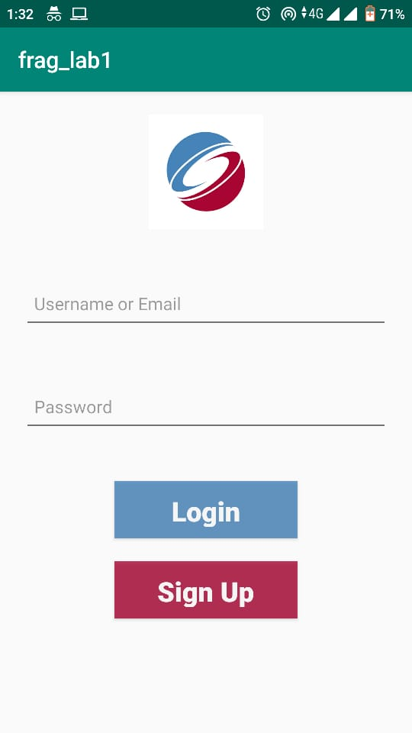

ADVANCE ANDROID

LAB-2

LOCALE

MainActivity.xml

<?xml version="1.0" encoding="utf-8"?>

<LinearLayout xmlns:android="http://schemas.android.com/apk/res/android"

xmlns:app="http://schemas.android.com/apk/res-auto"

xmlns:tools="http://schemas.android.com/tools"

android:layout_width="match_parent"

android:layout_height="match_parent"

tools:context=".MainActivity"

android:orientation="vertical"

android:layout_margin="20dp">

<TextView

android:layout_width="wrap_content"

android:layout_height="wrap_content"

android:layout_marginVertical="20dp"

android:text="@string/hindi"

android:textSize="30dp"

android:textStyle="bold"

android:textColor="#000"

android:layout_gravity="center"/>

<TextView

android:layout_width="wrap_content"

android:layout_height="wrap_content"

android:layout_marginVertical="20dp"

android:text="@string/urdu"

android:textSize="30dp"

android:textStyle="bold"

android:textColor="#000"

android:layout_gravity="center"/>

<TextView

android:layout_width="wrap_content"

android:layout_height="wrap_content"

android:layout_marginVertical="20dp"

android:text="@string/punjabi"

android:textSize="30dp"

android:textStyle="bold"

android:textColor="#000"

android:layout_gravity="center"/>

</LinearLayout>

String.xml

<resources>

<string name="app_name">himAnshuLab5Locale</string>

<string name="hindi">Hindi</string>

<string name="urdu">Urdu</string>

<string name="punjabi">Punjabi</string>

</resources>

Hindi.xml

<?xml version="1.0" encoding="utf-8"?>

<resources>

<string name="app_name">स्थान</string>

<string name="hindi">हिंदी</string>

</resources>

Urdu.xml

<?xml version="1.0" encoding="utf-8"?>

<resources>

<string name="app_name">مقامی</string>

<string name="urdu">اردو</string>

</resources>

Punjabi.xml

<?xml version="1.0" encoding="utf-8"?>

<resources>

<string name="app_name">ਲੋਕੇਲ</string>

<string name="punjabi">ਪੰਜਾਬੀ</string>

</resources>

Screenshots

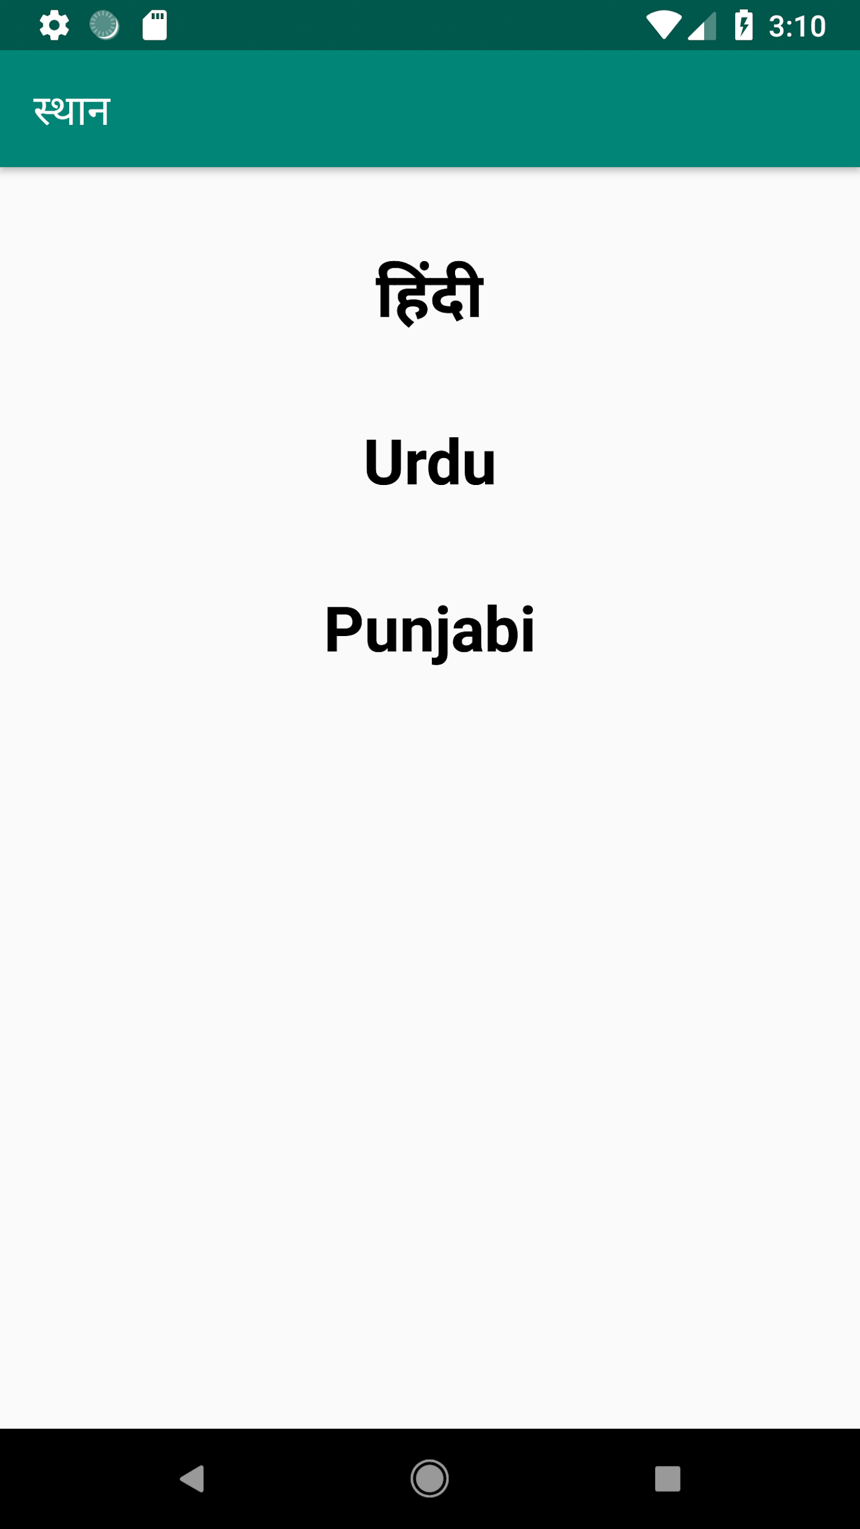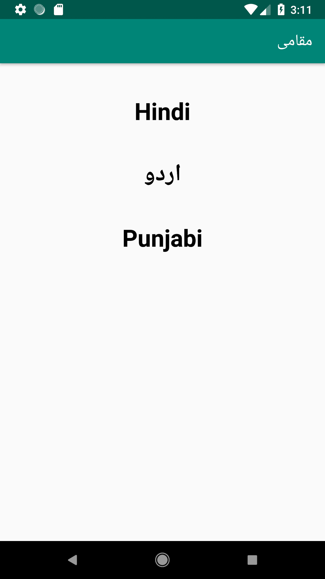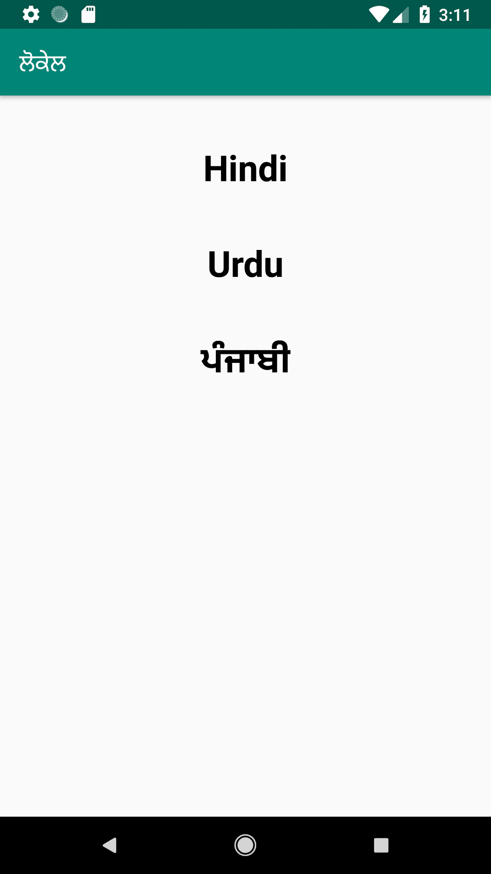

**ADVANCE ANDROID-II**

**LAB-3**

**Collapsing ToolBar**

**MainActivitY.xml**

**<?xml version="1.0" encoding="utf-8"?>**

**<android.support.design.widget.CoordinatorLayout xmlns:android="http://schemas.android.com/apk/res/android"**

**xmlns:app="http://schemas.android.com/apk/res-auto"**

**xmlns:tools="http://schemas.android.com/tools"**

**android:layout_width="match_parent"**

**android:layout_height="match_parent"**

**tools:context=".MainActivity"**

**android:fitsSystemWindows="true">**

**<android.support.design.widget.AppBarLayout**

**android:layout_width="match_parent"**

**android:id="@+id/app_bar"**

**android:layout_height="wrap_content"**

**android:fitsSystemWindows="true"**

**android:theme="@style/AppTheme.AppBarOverlay">**

**<android.support.design.widget.CollapsingToolbarLayout**

**android:layout_width="match_parent"**

**android:layout_height="match_parent"**

**android:id="@+id/toolbar_layout"**

**android:fitsSystemWindows="true"**

**app:contentScrim="?attr/colorPrimary"**

**app:layout_scrollFlags="scroll|exitUntilCollapsed">**

**<ImageView**

**android:layout_width="match_parent"**

**android:layout_height="300dp"**

**android:scaleType="centerCrop"**

**android:src="@drawable/dead"**

**android:id="@+id/expandedImage"**

**app:layout_collapseMode="parallax"**

**app:layout_collapseParallaxMultiplier="0.7" />**

**<android.support.v7.widget.Toolbar**

**android:layout_width="match_parent"**

**android:layout_height="?attr/actionBarSize"**

**android:id="@+id/toolbar"**

**app:layout_collapseMode="pin"**

**app:popupTheme="@style/AppTheme.PopupOverlay"/>**

**</android.support.design.widget.CollapsingToolbarLayout>**

**</android.support.design.widget.AppBarLayout>**

**</android.support.design.widget.CoordinatorLayout>**

**Main.java**

**package com.example.akibcollapsingtoolbar;**

**import android.support.design.widget.CollapsingToolbarLayout;**

**import android.support.v7.app.AppCompatActivity;**

**import android.os.Bundle;**

**public class MainActivity extends AppCompatActivity {**

**CollapsingToolbarLayout collapsingToolbarLayout;**

**@Override**

**protected void onCreate(Bundle savedInstanceState) {**

**super.onCreate(savedInstanceState);**

**setContentView(R.layout.*activity_main*);**

**collapsingToolbarLayout=(CollapsingToolbarLayout)findViewById(R.id.*toolbar_layout*);**

**collapsingToolbarLayout.setTitle("Deadpool");**

**}**

**}**

**Build.gradle**

**dependencies {**

**implementation 'com.android.support:design:28.0.0'**

**}**

**Styles.xml**

**<resources>**

**<style name="AppTheme" parent="Theme.AppCompat.Light.DarkActionBar">**

**<!-- Customize your theme here. -->**

**<item name="colorPrimary">@color/colorPrimary</item>**

**<item name="colorPrimaryDark">@color/colorPrimaryDark</item>**

**<item name="colorAccent">@color/colorAccent</item>**

**</style>**

**<style name="AppTheme.AppBarOverlay" parent="ThemeOverlay.AppCompat.Dark.ActionBar"/>**

**<style name="AppTheme.PopupOverlay" parent="ThemeOverlay.AppCompat.Light"/>**

**<style name="AppTheme.NoActionBar">**

**<item name="windowActionBar">false</item>**

**<item name="windowNoTitle">true</item>**

**</style>**

**</resources>**

**ScreenShots**

